Decidability : https://www.cs.rice.edu/~nakhleh/COMP481/final_review_sp06_sol.pdf
GATEOVERFLOW M-2

- https://gateoverflow.in/354740/gate-overflow-test-series-mock-gate-test-2-question-13
Use of relational operators such as > on nulls returns Unknown. The select operation filters out false and unknown values. 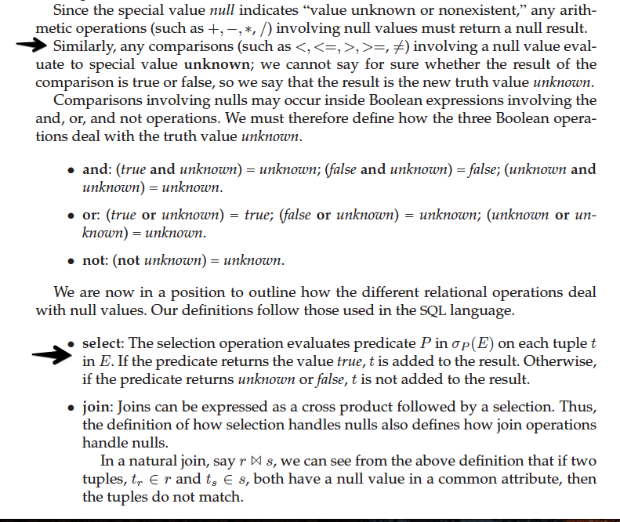https://gateoverflow.in/354740/gate-overflow-test-series-mock-gate-test-2-question-13

- https://gateoverflow.in/354728/gate-overflow-test-series-mock-gate-test-2-question-19

- https://gateoverflow.in/354726/gate-overflow-test-series-mock-gate-test-2-question-20

- https://gateoverflow.in/354710/gate-overflow-test-series-mock-gate-test-2-question-28

- https://gateoverflow.in/354702/gate-overflow-test-series-mock-gate-test-2-question-32

- https://gateoverflow.in/354700/gate-overflow-test-series-mock-gate-test-2-question-33

- https://gateoverflow.in/354698/gate-overflow-test-series-mock-gate-test-2-question-34
CEIL was a trap !!!!

- https://gateoverflow.in/354686/gate-overflow-test-series-mock-gate-test-2-question-40
- https://gateoverflow.in/354678/gate-overflow-test-series-mock-gate-test-2-question-44

- https://gateoverflow.in/354676/gate-overflow-test-series-mock-gate-test-2-question-45

- https://gateoverflow.in/354670/gate-overflow-test-series-mock-gate-test-2-question-48

- https://gateoverflow.in/354658/gate-overflow-test-series-mock-gate-test-2-question-54

GO M-6

- GATE Overflow for GATE CSE

- https://gateoverflow.in/394587/go-classes-test-series-2023-mock-gate-test-6-question-17

- https://gateoverflow.in/394574/go-classes-test-series-2023-mock-gate-test-6-question-24

- https://gateoverflow.in/394562/go-classes-test-series-2023-mock-gate-test-6-question-31

- https://gateoverflow.in/394558/go-classes-test-series-2023-mock-gate-test-6-question-35

- https://gateoverflow.in/394549/go-classes-test-series-2023-mock-gate-test-6-question-41

- https://gateoverflow.in/394541/go-classes-test-series-2023-mock-gate-test-6-question-47

- https://gateoverflow.in/394535/go-classes-test-series-2023-mock-gate-test-6-question-50

- https://gateoverflow.in/394527/go-classes-test-series-2023-mock-gate-test-6-question-5

- https://gateoverflow.in/394514/go-classes-test-series-2023-mock-gate-test-6-question-61

- https://gateoverflow.in/394508/go-classes-test-series-2023-mock-gate-test-6-question-65

GATEOVERFLOW M-3

- https://gateoverflow.in/355490/gate-overflow-test-series-mock-gate-test-3-question-25
Except for COUNT(*), SQL aggregate functions ignore null values
- https://gateoverflow.in/355478/gate-overflow-test-series-mock-gate-test-3-question-31

- https://gateoverflow.in/355475/gate-overflow-test-series-mock-gate-test-3-question-33
It is not necessary to have a final state in a DFA. The set of final states can be empty Or non-empty.

- https://gateoverflow.in/355473/gate-overflow-test-series-mock-aahttps://gateoverflow.in/355459/gate-overflow-test-series-mock-gate-test-3-question-41

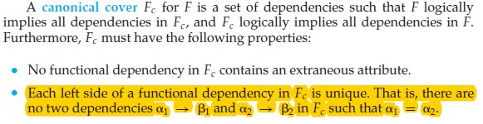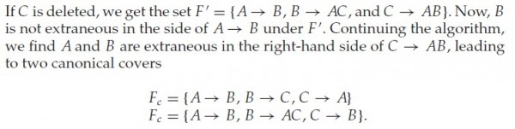
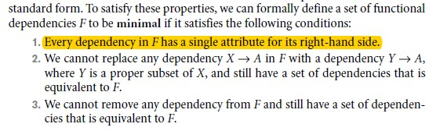
So, that means , minimal cover should have a single attribute on the RHS in all FDs .

And this is the only difference between canonical cover and minimal cover .

- https://gateoverflow.in/355451/gate-overflow-test-series-mock-gate-test-3-question-45

- https://gateoverflow.in/355447/gate-overflow-test-series-mock-gate-test-3-question-47

- https://gateoverflow.in/355439/gate-overflow-test-series-mock-gate-test-3-question-51
s[i] +2 is ignored as the return value is not stored anywhere.

- https://gateoverflow.in/355431/gate-overflow-test-series-mock-gate-test-3-question-55

- https://gateoverflow.in/355411/gate-overflow-test-series-mock-gate-test-3-question-65

GATEOVERFLOW M-4

- https://gateoverflow.in/356076/gate-overflow-test-series-mock-gate-test-4-question-63
- https://gateoverflow.in/356092/gate-overflow-test-series-mock-gate-test-4-question-55
- https://gateoverflow.in/356104/gate-overflow-test-series-mock-gate-test-4-question-49
- https://gateoverflow.in/356124/gate-overflow-test-series-mock-gate-test-4-question-39
- https://gateoverflow.in/356128/gate-overflow-test-series-mock-gate-test-4-question-37
- https://gateoverflow.in/356140/gate-overflow-test-series-mock-gate-test-4-question-31
- https://gateoverflow.in/356173/gate-overflow-test-series-mock-gate-test-4-question-14

AIMT 2

- https://gateoverflow.in/396725/go-classes-test-series-2023-mock-gate-test-8-question-24
- https://gateoverflow.in/396715/go-classes-test-series-2023-mock-gate-test-8-question-29
- https://gateoverflow.in/396709/go-classes-test-series-2023-mock-gate-test-8-question-32
- https://gateoverflow.in/396707/go-classes-test-series-2023-mock-gate-test-8-question-33
- https://gateoverflow.in/396702/go-classes-test-series-2023-mock-gate-test-8-question-36
- https://gateoverflow.in/396701/go-classes-test-series-2023-mock-gate-test-8-question-37
- https://gateoverflow.in/396699/go-classes-test-series-2023-mock-gate-test-8-question-38
- https://gateoverflow.in/396660/go-classes-test-series-2023-mock-gate-test-8-question-61
- https://gateoverflow.in/396664/go-classes-test-series-2023-mock-gate-test-8-question-59
- https://gateoverflow.in/396674/go-classes-test-series-2023-mock-gate-test-8-question-54
- https://gateoverflow.in/396678/go-classes-test-series-2023-mock-gate-test-8-question-52
- https://gateoverflow.in/396684/go-classes-test-series-2023-mock-gate-test-8-question-49
- https://gateoverflow.in/396687/go-classes-test-series-2023-mock-gate-test-8-question-46
- https://gateoverflow.in/396692/go-classes-test-series-2023-mock-gate-test-8-question-43
- https://gateoverflow.in/396695/go-classes-test-series-2023-mock-gate-test-8-question-41

GO M7

- https://gateoverflow.in/396401/go-classes-test-series-2023-mock-gate-test-7-question-8
- https://gateoverflow.in/396393/go-classes-test-series-2023-mock-gate-test-7-question-12
- https://gateoverflow.in/396378/go-classes-test-series-2023-mock-gate-test-7-question-20
- https://gateoverflow.in/396371/go-classes-test-series-2023-mock-gate-test-7-question-24
- https://gateoverflow.in/396362/go-classes-test-series-2023-mock-gate-test-7-question-29
- https://gateoverflow.in/396337/go-classes-test-series-2023-mock-gate-test-7-question-43
- https://gateoverflow.in/396327/go-classes-test-series-w2023-mock-gate-test-7-question-48
- https://gateoverflow.in/396315/go-classes-test-series-2023-mock-gate-test-7-question-55
- https://gateoverflow.in/396311/go-classes-test-series-2023-mock-gate-test-7-question-57
- https://gateoverflow.in/396295/go-classes-test-series-2023-mock-gate-test-7-question-65
- https://gateoverflow.in/396297/go-classes-test-series-2023-mock-gate-test-7-question-64
- https://gateoverflow.in/396301/go-classes-test-series-2023-mock-gate-test-7-question-62

Gateoverflow M6
- https://gateoverflow.in/370942/gate-overflow-test-series-mock-gate-test-6-question-23
- https://gateoverflow.in/370926/gate-overflow-test-series-mock-gate-test-6-question-31
- test-6-question-3https://gateoverflow.in/370916/gate-overflow-test-series-mock-gate-6
- https://gateoverflow.in/370910/gate-overflow-test-series-mock-gate-test-6-question-39
- https://gateoverflow.in/370908/gate-overflow-test-series-mock-gate-test-6-question-40
- https://gateoverflow.in/370906/gate-overflow-test-series-mock-gate-test-6-question-41
- https://gateoverflow.in/370898/gate-overflow-test-series-mock-gate-test-6-question-45
- https://gateoverflow.in/370897/gate-overflow-test-series-mock-gate-test-6-question-46
- https://gateoverflow.in/370884/gate-overflow-test-series-mock-gate-test-6-question-53
- https://gateoverflow.in/370882/gate-overflow-test-series-mock-gate-test-6-question-54
- https://gateoverflow.in/370876/gate-overflow-test-series-mock-gate-test-6-question-57
- https://gateoverflow.in/370922/gate-overflow-test-series-mock-gate-test-6-question-62

